
ISRAEL
Symposium

Proceedings of the Ed-ICT International Network Israel Symposium:
In Search of New Designs



Proceedings of the Ed-ICT International Network Israel Symposium:
In Search of New Designs
March 13-15, 2018

The Metropolitan Hotel, Tel-Aviv
The Open University of Israel, Ra'anana
M Metropolitan hotel, Tel-Aviv, Israel hotel, Tel-Aviv, Israel

Authors:
Tali Heiman
Dorit Olenik-Shemesh
Dana Kaspi-Tsahor
Merav Regev-Nevo

Copyright 2018 The Open University of Israel. This work is licensed under a Creative Commons license. Permission is granted to copy this publication for educational, noncommercial purposes, provided the source is acknowledged.
Table of Contents
Ed-ICT International Network 5
About the Ed-ICT Network <http://ed-ict.com/> 5
Israel Conference: Introduction 7
Activities 7
Conference focus 7
Opening: Professor Tali Heiman, The Open University of Israel 9
Topic 1: ICT implementation in the lives of young adults with disabilities 10
Professor Jane Seale (The Open University, United Kingdom) Making higher education more accessible to disabled students: Do we need new technologies or new technology practices? 10
Overview 10
Take-home messages 11
Dr. Carmit-Noa Shpigelman (University of Haifa, Faculty of Welfare & Health Sciences) The meaning of technology in the lives of young persons with disabilities 12
Overview 13
Topic 2: New design of assistive technology in higher education in Israel: Various perspectives 15
Dr. Moshik Lavie (The Open University of Israel; Dean of students) 15
Mrs. Michal Rimon (Access Israel, CEO)- Accessibility in the Digital Era 16
Mrs. Michal Shik Har-Tuv (Head of Legal Department, the Open University)- Accessibility of internet services in Israel 18
Mrs. Elana Banish (Accessible consultant, Israel)- Improving the accessibility in services-based bot - web robot. 19
Mrs. Michal Walter Levi (Google Israel)- Accessible applications: To be equal among equals 20
Topic 3: Individual and Social Experience of Students With Disabilities with ICTs 22
Dr. Nitzan Almog (Ono Academic College, Israel) Social aspects along the academic journey of students as related to technology 22
Mrs. Hadar Zeltzer-Fallah (Vice President, Dagesh, Israel) Assistive technology- From trying to doing 23
Topic 4: Challenges and Facilitators for Promoting New Designs in ICTs in Higher Education: Future Directions 26
Prof. Lilach Shalev-Mevorach (Tel-Aviv University, Israel) Eye-tracking reveals difficulties in reading comprehension of students with ADHD: New findings and future directions 26
Overview 27
The Study 28
Attention Training: 29
Dr. Sigal Eden (Bar-Ilan University) Students with intellectual disabilities attending regular courses 29
Overview 30
Educational Goals 31
Occupational Outcomes 31
Topic 5: Advanced, Innovative Technologies and New Designs 32
Mr. Idan Meir (CEO “Right Hear“, Israel) - "Open Your Eyes" How technology improves the lives of the blind and visually impaired 32
Mr. Elihav Rodman (ORCAM Technologies, Israel)- "See for yourself" - Camera for blind and visually impaired people 33
Mrs. Goly Rabbanim (Head of Digital Accessibility, The Open University of Israel) - Inclusive videos in E-Learning and sites accessibility 35
Dr. Betty Shrieber (Kibbutzim College of Education, Technology and Arts, Israel) Using mind-mapping software to initiate writing tasks and organizing ideas for students with SLD and ADHD 37
Mrs. Iris Adato-Biran (Kiryat Ono Acadmic College, Israel) Assistive technology for learning applications: trends and challenges 38
Panels 40
International Panel - International Perspectives 40
Student Panel - Student Perspectives on Search for New Designs 46
Discussion 52
Discussion – Day 1 52
Discussion – Day 2 55
Summary 58
Keynote Presenters 58
International Panel 59
Student Panel 60
Symposium Participants 62
Acknowledgements 64

Ed-ICT International Network
Disabled Students, ICT, Post-Compulsory Education & Employment: In Search of New Solutions
Israel Symposium: In Search of New Designs

About the Ed-ICT Network <http://ed-ict.com/>
The focus of the Ed-ICT International Network is to explore the role that information and communication technologies (ICTs), including computers, assistive technologies, online learning, and social networking sites play, or could play, as facilitators or barriers for students with disabilities in post-secondary education; specifically in relation to social, emotional, and educational outcomes.
Funded for three years by the Leverhulme Trust, this international network is co-organized by Jane Seale, Principal Investigator (The Open University, UK); Catherine Fichten (Dawson College, Canada), Tali Heiman (the Open University, Israel); Sheryl Burgstahler (University of Washington, Seattle); and Björn Fisseler (FernUniversität, Germany).
The Network examines the practices that educators and other stakeholders implement to mediate successful and supportive relationships between learners with disabilities and ICTs.
The Network’s objectives are to:
- Synthesize and compare the research evidence that is available across the five countries regarding the relationship between students with disabilities, ICTs and post-secondary education;
- Construct theoretical explanations for why ICTs have not yet brought about the reductions in discrimination, disadvantage and exclusion that were predicted when equality and discrimination-related laws were published across the five countries;
- Provide new perspectives about potential future solutions regarding how post-secondary educational institutions can better use ICTs to remove the ongoing problems of disadvantage and exclusion of students with disabilities.
In order to meet these objectives, the Network will hold five international symposia with five broad themes:
- Effective models, frameworks
- Stakeholder perspectives
- New designs (Israel meeting 2018)
- Effective practices
- New solutions

Israel Conference: Introduction
The purpose of the Israeli symposium was to examine how new and different ICT designs can contribute to the academic, social, and physical needs of individuals with various disabilities in postsecondary institutions. The meeting also focused on innovative technologies and future directions, accessibility and new trends, and challenges for students with disabilities.
The conference included five sessions, two panels, and two comprehensive discussions at the end of each day. A variety of experts were invited to share their academic and personal experiences, including specialists from The Open University of Israel (OUI); the OUI Dean of Students; technology specialists; directors from private industries who have developed specific assistive technologies for the blind; academics, who presented their research studies; representatives from the OUI legal department; and students with disabilities.
The principal investigator of the Ed-ICT Network is Jane Seale. The Israel Conference coordinator members were Tali Heiman, Dorit Olenik-Shemesh, and Dana Kaspi-Tsahor from The Open University of Israel.

Activities:
- Five sessions with 16 speakers
- Two panel presentations (international perspectives, and student perspectives)
- Two discussions
Conference Focus:
The two-day conference focused on innovative directions in information technology for students with disabilities in higher education from an international perspective, and emphasized the development and implementation of new technologies for assisting students with disabilities in higher education.

We sought answers to questions such as:
- What are the barriers and facilitators of information and communication technologies (ICTs) for individuals with disabilities in post-secondary education?
- How are the ICTs implemented in the lives of students? What are the barriers and what helps them?
- Different perspectives of the delegates regarding new design
- Different perspectives of students with disabilities regarding ICTs?
- How do the new designs improve the ability of students to cope and adjust to academic and personal inclusion in society?

Opening: Prof. Tali Heiman

The Open University of Israel

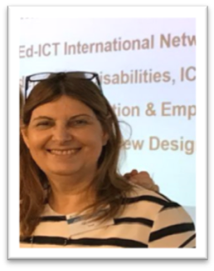
Prof. Heiman presented the main topics of the third meeting, based on the Ed- ICT international network's goal of improving the standards of ICTs and supporting students with disabilities. The purpose of the study is to synthetize and compare the research evidence regarding the relationship between students with disabilities and ICT's in higher education.

Professor Tali Heiman (The Open University of Israel; Department of Education & Psychology)
Opening remarks
- The purpose of the conference is to understand and promote ways to support students with disabilities. We will seek to synthesize and compare research regarding the relationship between students with disabilities, and information and communication technology in higher education.
- The Open University is the largest university in Israel, with about 45,000 registered students. Our uniqueness lies in the way we mix digital, accessibility components, and technology for our students. During 2017, 861 students with disabilities studied at The Open University, including 51 with hearing impairments, 82 with visual impairments, 244 with motor disabilities, 372 with severe chronic illnesses, 129 with mental illnesses and about 3,000 with diagnosed learning disabilities and/or ADHD.

Topic 1: ICT implementation in the lives of young adults with disabilities

Prof. Jane Seale, The Open University, United Kingdom:

Making higher education more accessible for disabled students: Do we need new technologies or new technology practices?
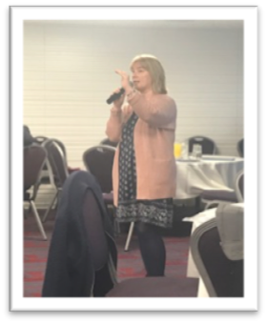
Professor Seale's academic work has focused on learning technology for nearly three decades. Between 2000 and 2002 Jane set up the first-ever UK-based Masters in Assistive Technology at Kings College, London. In 2010, Jane became Professor of Education at Plymouth University, moving in 2013 to take up the position of Professor of Inclusive Education at Exeter University. Jane joined the OU in April 2016. She has served in key roles such as President of the Association for Learning Technology (2006-2007) and Digital Inclusion Consultant to the ESRC-funded Technology Enhanced Learning (TEL) Program in the UK (2009-2012).

Overview
- Prof. Seale began the lecture by saying that what she was about to propose as a critical thinking frame would no doubt make her listeners uncomfortable: Do we really need new design, or do we need new people and practices?
- Research regarding the accessibility of different universities in different countries, including Canada, the US, and the UK, shows that the accessibility of their websites is still poor.
- We can talk at length about different designs, but what must be discussed is where and how these designs are to be implemented and used. For example, what are the chances of using the existing caption system if universities do not even follow basic guidelines required to make their websites accessible?
- There is no lack of academic work that focuses on accessibility for various populations. However, the underlying question here is whether our community is really willing to do what it takes to become truly accessible for people with disabilities? What is needed is a concept of openness similar to what is found in social media and open source technologies. Technologies that can be put online and that people can change and adapt them for themselves.
- In the 1980s I was working in England when a movement was founded for special needs which managed to inspire the teaching communities in the country. They wrote a program that was called BBC micro and made it available so people could copy the software and send it for free.
If you read the literature of special needs you will see how brilliant it was: A teacher who knew nothing about programming could copy the software and use it with her students. This is inspiring. I think we should follow such examples, and try to cascade our programs.
- When we think of design, we need the designers to be empathetic to the disabled. Some people say we need to make sure that designers have the opportunity to meet disabled people, and to interact with them. We need to simulate disabilities properly, so they can have a better understanding of the needs and challenges involved.
- On the academic level, more research needs to be conducted to understand the lives and needs of disabled people, to get a better understanding of compatible solutions. Currently, too much of what we offer is based on assumptions and values; these solutions should become evidence-based.

Take-home messages
- Our main challenge lies in turning the abstract theoretical solutions we have into practice. Otherwise these solutions are useless.
- We need technological companies, on every level, to become involved in order for change to take place – not only programmers and designers, but even stakeholders.
- People with disabilities should get involved with new technologies from the start – not only as focus groups and clients, but as designers and developers.
- Open source technology should be an inspiration when we develop new accessibility technologies.
- We need to educate future generations accordingly; let's change the computer science curriculum. We also need to simulate disabilities in the real world for the designers, so they'll be truly empathetic to disabled people.
- The academic community should conduct more thorough research on disabled people's lives and needs so we can build better, evidenced-based technology.

Dr. Carmit-Noa Shpigelman – University of Haifa, Faculty of Welfare & Health Sciences:

The meaning of technology in the lives of young persons with disabilities

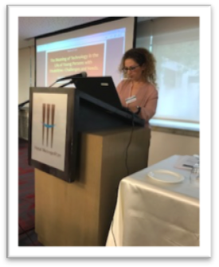
Dr. Shpigelman specializes in interdisciplinary research which links rehabilitation, education, disability studies (mental health and inclusion) and technologies. She is interested in promoting social awareness and policy change for mental health as experienced by underserved populations, particularly people with disabilities. Dr. Shpigelman's lecture was based on research conducted with Dr. Bergman.

Overview
- Through this research we wished to find out what the use of accessible technologies meant for people with disabilities.
- A recent Israeli report showed that only 58% of adults with disabilities use computers. This shows us the digital divide between people with disabilities and the rest of the population. Usage is growing, though: Another report from 2012 showed that 64.8% of people with disabilities used the internet, compared to only 36.3% in 2005.
- There are two main types of digital divide. The first, primary digital divide, is limited access to technology. The secondary digital divide is limited use of technology. Do I have the knowledge and the required skills?
- Our research focused on visually-impaired people, 73% of whom had academic degrees, and 55% of whom were employed. All reported using the internet for communication and navigation applications.
- Many participants said that when using the internet they feel equal to others. They also referred to equality in occupational settings, and to the way technology enables them to do things they couldn't do in the past.
- There is also a darker side. At times, technology placed our participants at a disadvantage. An example might be an employer who wants to hire a blind person and attempts to install zoom text but doesn't succeed. In such cases, technology limits the participation of people with disabilities.
- Participants also talked about leading independent lives, using technology without asking others for assistance. Due to inaccessibility issues they still depend on others to operate technologies. This can also raise questions of privacy, such as when communicating with the bank or with health care professionals.
- Technology makes life easier; one almost cannot exist without it. Technology is empowering. It allows people with disabilities to do the things they need to do.
- Those thinking about accessibility technologies have to take into consideration the people themselves, how they see themselves, and the relevant technologies.
- It is important to understand how people with disabilities experience technology, and what it means to them.
- A digital divide exists between people with and without disabilities; this gap should be closed.
- Technology usage can empower and help, but it can also limit and underscore differences between those with and without disabilities.

Topic 2: New design of assistive technology in higher education in Israel: Various perspectives

Dr. Moshik Lavie – Dean of Students, The Open University of Israel
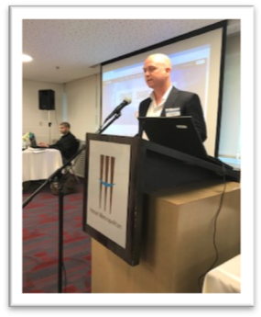
Opening Remarks
- The Open University has been home to students with disabilities since the 1980s. We implement new technologies and strive to increase awareness of accessibility among our employees and staff. We are very proud of our students, some of whom you'll hear about later.
- I would like to introduce David, a student at the Open University who has a visual and hearing impairment, and who uses a wheelchair. In order to read the textbooks required for the courses he has to receive special files.
- David, a student said: "In the past, I studied computer engineering in another university but had to quit, as I have difficulties due to my disability. Unfortunately, I couldn't access all the required textbooks – someone had to transcribe for me. If I had access to all of the required materials I could have graduated long ago. Cases such as mine highlight the gaps of the accessibility of digital books and lessons; sometimes they are fully digital".

Mrs. Michal Rimon – Access Israel

Accessibility in the Digital Era

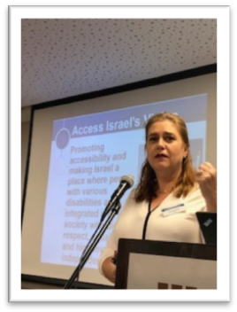

Opening remarks
Access Israel was founded by Mr. Yuval Vagner. Nineteen years ago, Yuval, who served as a pilot during his IDF army service, was involved in a helicopter crash. He survived but has been using a wheelchair ever since. After discovering that a hotel bathroom was too narrow to accommodate his wheelchair, Yuval contacted Mr. Ezer Weitzman, then President of Israel and a fellow veteran pilot. Six months later, Access Israel was established in the president's official residence.

Overview
- Access Israel began raising awareness of accessibility issues, which are very complex, since a solution which works for one person is not necessarily a compatible solution for another, and might even be an obstacle.
- When Access Israel began its work, everybody concentrated on physical and service accessibility. It is clear now, that these alone aren't nearly enough. Social accessibility is, however, truly changing the DNA of our society. The newest dimension is technological accessibility.
- Technology is particularly important for implementation: holograms, robots, smart houses, and autonomous cars will provide the best service when all people use them. However, these are not necessarily accessible. Think of cars: People with disabilities will be left without transportation because cars will not be accessible to them. A ramp is not enough. What about a deaf person? How will he communicate with the car – by typing in comments? And what will a blind person who needs vocal communication do?
- I am referring specifically to two types of technology: Technologies based on accessibility, and "regular" technologies, which we need to make sure are accessible too.
- People with disabilities comprise between 15 to 25 percent of the population. A survey by Microsoft found that about 50 percent of this population will not use their software.
- Our goal is to make Israel technologically accessible by design: Turn Israel into an accessible start-up nation which serves as a model for this concept.
- The Access Israel organization is focused less on assistive technology and more on the public realm. We want innovation centers to enable start-ups and other companies to understand the needs of people with disabilities.
- We also offer consultation, and we have a lot of international activities. We understand the importance of ICT for people with disabilities.

Take-home messages
- Israel has made many advancements with regard to accessibility issues, but there is still a very long way to go. A lack in awareness and understanding still remains.
- Accessibility issues for various populations need to be taken into consideration when we plan new technologies.
- All technology needs to be accessible – not only technologies designated for people with disabilities.
- An accessible business is a winning business.
- Let us not leave anyone behind.

Mrs. Michal Shik Har-Tuv –Head of Legal Department Accessibility of internet services in Israel

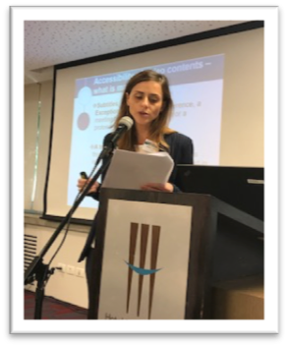
- More and more things that we do in life involve technology and especially, the internet.
- I will present the requirements for making the internet and mobile apps accessible for people with disabilities.
- Accessibility should be regulated. In Israel we have the 1998 Equal Rights for People with Disabilities Law; an accessibility chapter was added in 2005. The service accessibility regulation passed in 2013. Regulation no. 35 makes it mandatory to make all apps and internet accessible; it obligates platforms of websites to be accessible, including HTML documents, pdf, Microsoft Word and videos. This regulation is valid as of October 2017. Websites of public institutes, such as universities, are required to become accessible by October 2018.
- Many of the guidelines are dedicated to visually impaired and blind people. There are many difficulties, however, associated with implementing the law: there's no solution for scanning documents, for example.
- According to the regulations, academic courses and the platform should be accessible, however the content is not required to be accessible in advance.

Mrs. Elana Banish –Accessibility Consultant, Israel

Improving the accessibility in services-based bot-web robot

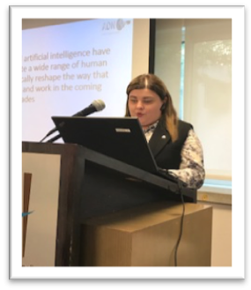
Elana is an Open University graduate with an MA in learning technologies. She is an accessibility authorizer who specializes in the accessibility of internet and ICT technologies.

Overview
- Bots such as Siri and Alexa are changing our lives. It is an ever-expanding field, and almost every technological device can be controlled today through service bots and voice commands.
- Service bots can help people with physical and cognitive disabilities.
- A few months ago I encountered an inaccessible bot in one of my cellular programs. This is a bot that offers answers in the form of picture text; since I can't see the screen and I use a voiceover and a Bluetooth earphone, I couldn't use it.
- We must teach bots the basic concepts of accessibility. That is work that should be done with programmers of accessibility; to see how to implement WCAG 2.0 based on bots.
- We must insure that the information that the bot gives us will be based on a live text, not an image. When a screen reader sees an image, it cannot read it.
- We have to make sure that the interface allows people with motor disabilities to navigate with no keyboard and we have to use simple language so people with cognitive disabilities can understand interface and interact with the bot.
- With WCAG 2.0, we can see that it addresses more than one type of disability. It is accessible for visually impaired and blind people, people with motor disabilities, and also people with cognitive disabilities.
- We can see that, even in 2008, the aim was to create inclusive accessibility in the internet as much as possible, in service-based bot and ICT technologies, so in the end, everybody will be able to use a WCAG framework to implement accessibility in the interface.

Mrs. Michal Walter-Levi –Google Israel

Accessible applications: To be equal among equals

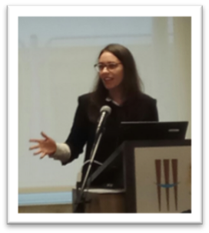
Overview
- In Google Israel we have the possibility of dedicating 20% of our working time to whatever we want. So five years ago we opened the campus in Tel Aviv. A place for investors, and accelerators; people that help start-ups.
- Three years ago I met people from Beit Issie Shapiro http://en.beitissie.org.il/about/in-a-nutshell/. I didn't know much about people with disabilities, so when they presented the statistics I was shocked and amazed. Twenty percent of the US population is made up of people with disabilities! How come we don't deal with that?
- There is less information about mobile apps, so we decided to open testing labs with people with disabilities, trained mentors, and start-ups, which would observe in order to see how people with disabilities are using their apps, and to learn about accessibility.
- One of the first apps we worked with was Moovit. Making public transportation accessible is important. The outcome of this work was that Moovit became the official app for the Olympics because they were the only accessible app.

Take-home messages
- We are all here to educate students but we also need to educate the industry. Accessibility is not only beneficial for the community, but also for your business.
- To be very accessible to start-ups all over the world, we put guidelines on our website.

Topic 3: Individual and Social Experience of Students with Disabilities with ICTs

Dr. Nitzan Almog – Ono Academic College, Israel

Social aspects in the academic journey of students as related to technology

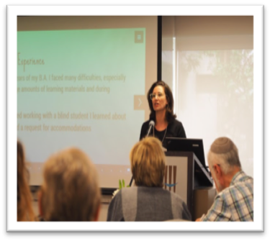

Dr. Nitzan Almog began her talk telling about her own experience as a BA student with a visual impairment who was faced with many difficulties in reading the huge amount of required materials and in taking exams. She shared her difficulties as a student in higher education institutions in reading the texts and filling in forms. She explained her research, based on the experiences of students with disabilities who have to deal with technology in higher education.
Overview
- Is technology the only answer? There are many more needs, such as increased study time; increasing complexity of academic demands; a variety of learning materials and platforms; gaining independence.
- Some technology is dependent on human assistance. Students with disabilities, no matter which kind, always have many learning materials and platforms that need human assistance. In addition, the value of independence in Israel is not always clear. What is independence for students with and without disabilities? Dr. Almog presented an example of a student with a visual impairment that exemplifies how we need human help for using technology and in daily life.
- Building inclusive environments in higher education: If students with disabilities wish to work with a computer in the university or need to write a paper, they cannot do it by themselves, as it is not accessible.
- Inclusive environment – AT should be everywhere.
- Policy as a barrier: Policy issues are often a barrier. Many students describe difficulties due to discriminative policies. The procedures are complex and slow, and there are many policy issues that need to change in order to make student lives easier. We must remember that the laws and regulations are still in their infancy. Higher education and state policies should reflect more accommodations and enabling regulations.
- The use of AT enables students in higher education not only to receive help, but also to offer help to others by becoming group members, thus sharing responsibilities and credits. While using AT, students can confront the question of whether to share their disability or to pass as non-disabled.

Mrs. Hadar Zeltzer-Fallah – Vice President, Dagesh

Assistive technology – From trying to doing

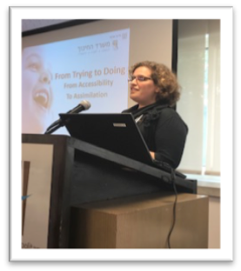

Hadar Zeltzer-Fallah began by describing her work of thirty years in the education field, followed by a stint in Hi-tech, before moving to the field of assistive technology.
She introduced the Dagesh organization, which places an emphasis on providing solutions that are suited to people with disabilities, offering them the latest technologies and computerized systems, in order to improve their lives through exploring new technologies, importing solutions, marketing them to the Israeli market, and advising organizations on the proper use and the right solution to each end-user.
Dagesh AT specializes in solution customization for specific end-user needs through a procedure called an "accessibility assessment session" during which experts observe the end-user, gain an understanding of the user limitations and capabilities, and experiment with a number of solutions. The end-user evaluates the solution during a loan period that helps him or her become accustomed to the solution and makes sure it meets the end-user's needs. Dagesh specializes in AAC (augmentative and alternative communication) solutions, 'Eye Gaze Systems', communication devices, switches and accessible environment control, special keyboards, mouse replacements, and music therapy, thus helping students with disabilities in higher education institutions. Dagesh is the leading solution provider in Israel for people with special needs at the Ministry of Health, Ministry of Education, National Insurance, Ministry of Defense and many technology organizations.

Overview
- Cooperation is key. No matter the need and cognitive challenge we are dealing with, you do not want anything to take place "about you without you." In the education system, it is society's obligation to help students achieve their goals, in every age group and at every educational level.
- Technology is not enough. As in cooking, when one wishes to bake a good cake, it does not matter if it is by hand or by electric mixer, but the important issue is to put the right ingredients in and mix it well.
- Hi-technology is not always the best technology. In Israel, the Ministry of Education took on the responsibility of providing computers as access tools to notebooks. Now that students have accessibility all the way from kindergarten to higher education, it can be seen that the content is not always good enough, but we still do not have a tool for checking content.
- From 2016, every student has the right to receive assistive technology, from kindergarten to age 21, provided by the Ministry of Education. In Israel, 9,000 requests for AT were fulfilled. Many people took advantage of assistive technology without considering it deeply.
Examples:
1. Rivka, who is a blind student, knew what she wanted. She could not see from anywhere in the classroom, since she needed to see things from up close, and has low motor function. Cognitively, Rivka has no problems, but her frustration made her speech unintelligible to other people. Back then we did not have TTC, so Dagesh recorded every word on the board and gave her a touch pad. She could then do everything.
2. Yuval is a graduate student with a physical disability so severe that he was only able to use his tongue. We offered him a microlight to put on his head. His teacher made changes in the classroom, so now he can be a full participant in class.
3. Gal was a good software engineer, with the personality of a pioneer. He decided to continue to do everything to help people with physical impairments. He developed click2speak, https://www.click2speak.net/download-sw which is downloadable and accessible in every language.
4. Shir is a 4-year-old girl who has a hearing impairment. Shir's classmates don't understand her, but her mother and the therapist assist her with a joystick, pad, and keyboard, which serve her and which she uses all the time. She asked for a computer for communication.

Topic 4: Challenges and Facilitators for Promoting New Designs in ICTs in Higher Education: Future Directions

Prof. Lilach Shalev-Mevorach – Tel-Aviv University

Eye-tracking reveals difficulties in reading comprehension of students with ADHD: New findings and future directions

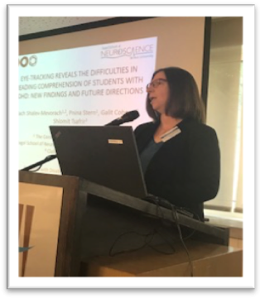

Prof. Shalev-Mevorach mainly addressed the topic of ADHD and whether patterns of eye movements can help us detect ADHD in students. Neuroscience and learning is an emerging field, developing rapidly, and including various areas relevant to learning.

Overview
- Sustained attention is the ability to focus attention over a long period of time. The length of the activity can cause difficulty. "Attention" refers to much more than what is generally thought. We have different functions and attention is necessary for a variety of inputs to all sorts of learning. It has many more functions than just academics and higher education.
- When coping with attention deficit, the nature of the task or activity is essential. When the task is challenging, a lot of mental effort is invested in it, but when the task is simple, requiring automatic processing, it may become an obstacle to staying focused. Each one of us can think of different times when we struggled to stay focused, however, one sector of the population – individuals with ADHD –really struggle.
- In the last two decades, there has been a significant increase in the research and strategies for managing ADHD, a positive change in helping this group of students. Nowadays, we see a higher percentage of people with ADHD. The Open University of Israel provides an excellent example of higher education helping these students to study and integrate.
- The Israeli Council of Higher Education provides support in higher education for students with ADHD and learning disabilities, and there is a substantial movement towards recruitment and a willingness on the part of various higher education institutions to support their learning.
- Students with ADHD suffer from various difficulties. The main obstacle is to be able to read efficiently. The goal of the research team of Prof. Shalev-Menorah is to try to identify the causes of the common phenomenon known as "mindless reading," in which comprehension takes longer.
- The challenge and main goal of the study was to identify inattentive reading using eye movements. Very few studies have found that typically developed readers spend more time attentive to the text. In lexical effects, being engaged in reading and spending more time on highly frequent words, defines "mindless reading." Very poor sustained attention is present and substantial parts of the text are not perceived. The implications of attention deficits are dramatic.
- Emerging evidence shows that the study of small involuntary eye movements is a promising new tool for shedding light on the hidden workings of mental processes such as attention and anticipation; cognitive processes that are often impaired in individuals with ADHD.
- Carefully tracking eye movements offers a new method for empirically monitoring temporal expectation in people with ADHD. The study shows that the continuous stream of eye movements is temporarily paused before an anticipated visual event and that the attenuation in eye movements can be used as an estimate for whether and when the occurrence of regular events was indeed predicted.
- The research team of prof. Shalev- Menorah found that individuals with ADHD tended to not attenuate their eye movements before a predictable event, which suggests that they were not able to predict the event or to act upon predictions. They suggest that careful analysis of eye movements may offer an objective measure to complement other tools used for diagnosis and assessing treatment efficacy.

The Study
For their study, the research team collected data from a group of twenty participants who had received an ADHD diagnosis, and a group of twenty typical controls. Those in the ADHD group were asked to stop taking any ADHD-related medication for 24 hours prior to the testing sessions.
On two different days, participants were shown a series of colored shapes on a screen while their eye movements were monitored. The participants were instructed to press a key whenever they saw a red square (which appeared around 25% of the time). On one day, participants were shown the shapes at predictable intervals: Every two seconds the next shape would appear. On the other day, the time lapse between shapes varied from 1 to 2.5 seconds. Participants were not told that the timing would be different during the two sessions.
When the stimulus appeared at regular, predictable intervals, those in the control group responded more quickly than when it appeared at varied intervals. However, the reaction times of those with ADHD did not improve under predictable conditions.
The researchers also found that those in the control group tended to have fewer eye movements immediately before a predicted event. In contrast, those in the ADHD group did not show the same eye movement slowdown in preparation for an upcoming stimulus.
The research group also discovered that an ADHD diagnosis was not the best predictor of an individual’s ability to stay focused on the task. The individual ability to stay focused throughout the task was a better predictor for the attenuation of eye movements than whether or not that individual was diagnosed with ADHD. This finding demonstrates the importance of assessing the specific neuropsychological functioning of each individual, and thus, the study highlights the potential use of eye movements as an objective measure of temporal expectation.

Attention Training:
For everyone, being attentive is very important and can be improved. The first stage of a unique intervention study was introduced: Among typical students, without ADHD, the ability to sustain attention is good and can be seen in eye movements. Among students with ADHD, this is the first stage of a unique intervention study and the students with ADHD showed substantial improvement after attention training. Further results are bring processed these days.

Dr. Sigal Eden – Bar-Ilan University

Students with intellectual disabilities attending regular courses

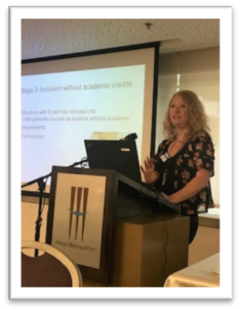

Dr. Eden presented research about students with Intellectual Disabilities (ID), using technology from tablet applications and V.R robots that are integrated in regular classes in Bar-Ilan University.

Overview
- In Israel, more than half a million adults have developmental disabilities, which amounts to 10% of the Israeli population in these age group, which is a large number of people. Only 18% percent are able to earn a BA degree, as compared to 32% of the non-intellectually-disabled Israeli population. So, it is essential to promote laws and policies that will ensure participation in educational and vocational frameworks. The school of education at Bar-Ilan University has put these rights into action.
- Educational opportunities in PSE were unavailable for adults with developmental disabilities or populations that did not meet the criteria for traditional matriculation (Plotner & Marshall, 2015).
- Promoting laws and policies that will ensure participation in all educational, vocational, leisure and other settings in the cultural community for people with disabilities via intercultural dialogue (TASH, 2010).
- A special inclusion project at Bar-Ilan University: The school of Education is running a special project that includes four stages of empowerment and inclusion for people with intellectual disabilities in the academic world. The research for the evaluation of the project is in its initial stage.
The four stages are as follows:
- Adapted enrichment courses - students in a group with a special teacher that teaches them about self-advocacy. There is inclusion, but in a group that can meet together. Students with ID participate in academic enrichment courses. The lecturers are MA students in the ID track. Courses include Psychology, Sociology, Self-advocacy, and Ecology.
- Inclusion in a research seminar - mutual learning between the two groups. The two groups conduct analysis together. Students with ID are included in a BA research seminar with typical students. The students with ID interviewed their friends and the two groups analyzed the results together.
- Inclusion without academic credits - Students with ID are fully included in undergraduate courses as auditors without academic requirements. The students attend all classes and integrate with regular students. They do everything like other students, without any other requirements.
- Full Inclusion - In Stage 4, highly capable students with ID are fully included in all academic courses, take exams like any other student, perform class tasks, and receive academic credits; they can choose the courses, receive access to university libraries, and conduct small-scale research projects with regular students. In these classes they study English, Hebrew, Language and Judaism. Ten percent of students with ID are included in full integration.

Educational Goals
  - Opportunity for students with ID to study in an academic environment.
  - Acquire knowledge on academically relevant subjects.
  - Have access to the university's libraries.
  - Conduct small-scale research projects.
  - The goal: to identify these individuals and allow them to fulfill their potential.
Social Goals:
- Exposure to typical students during class and breaks.
- Empowerment, self-image, confidence, and quality of life.

Occupational Outcomes
Adults with developmental disabilities who have had the opportunity to participate in inclusive post-secondary education typically find better jobs of their choosing at better pay, require less human service support, and keep their jobs longer than individuals who have sought employment through more traditional human service avenues.” (Hughson & Uditsky, 2012)

Topic 5: Advanced, Innovative Technologies and New Designs

Mr. Idan Meir – CEO, Right Hear Israel

Open your eyes: How technology improves the lives of the blind and visually impaired

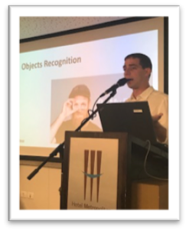
Idan Meir is the CEO of Right Hear Israel, a software company developing accessibility solutions for the blind and visually impaired. Further information on Right Hear Israel can be found at https://right-hear.com. Mr. Meir began by telling about his friend Adi, who is blind, and who works as a software developer, and who is about to become a student at The Open University of Israel. How can technology assist Adi's everyday life and promote his independence?
Overview
- Adi's daily life is enormously improved, thanks to various technologies which are used by the general population and are also accessible to the blind and visually impaired, such as Whatsapp, Facebook, Gett, Moovit, etc.
- However, many environments such as shopping malls, museums, and universities remain essentially inaccessible, forcing the visually impaired to rely on the assistance of sighted people.
- Right Hear maps specific environments, using multiple sensors and auditory guidance to inform visually impaired people of their immediate physical surroundings, providing both general factual information (i.e. "This is room 301") and specific instructions (i.e. "three stairs are ahead').
Take-home messages
- Technology can, and does, improve the lives of the blind and visually impaired.
- Technologies such as social media, apps. etc. are already accessible; yet society as a whole isn't.
- To truly enable blind and visually impaired people to become independent, we need to establish a holistic approach to accessibility issues.
- Orientation and object recognition are of paramount importance to our daily lives. Right Hear wishes to promote accessibility for the blind and visually impaired by making specific objects and processes, as well as entire environments, recognizable and accessible.

Mr. Elihav Rodman – ORCAM Technologies, Israel

See for yourself: A camera for blind and visually impaired individuals

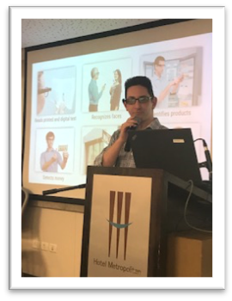
- Orcam relies on artificial vision and computer vision technology to aid blind and visually impaired people recognize objects and texts in their surroundings. Further information on Orcam can be found at https://www.orcam.com/en/

Overview
- Orcam My eye 2.0 is a wearable, relatively small device that can be worn over a pair of glasses. It can recognize and name basic objects (such as consumer goods). Currently the device reads and speaks 15 languages, and can be taught to recognize new objects according to the personal needs of each users (such as facial recognition of friends and family).
- If Orcam My eye 2.0 were to read everything in its field of vision it would be impractical; therefore it will read texts out loud only if specifically requested by the blind person.
- Asking Orcam My eye 2.0 to read or recognize a specific object is done by a simple, non-verbal and intuitive gesture. This way, the user doesn't have to consistently address the device with spoken commands.
- All information is saved in the device itself and isn’t connected to the internet. This also means it can be used in any environment without data security concerns.
- Using Orcam My eye 2.0 has allowed a sample of blind and visually impaired participants to become much more independent in their daily lives.
- Orcam My eye 2.0 currently costs 4500 $ per unit. It is funded by non-profit organizations and not by its users.

Mrs. Goly Rabbanim – Head of Digital Accessibility, The Open University of Israel

Inclusive videos in E-Learning, and site accessibility

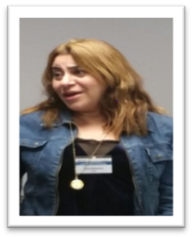
Mrs. Rabanim, an accessibility consultant, is responsible for accessibility at SHOHAM – the Center for Technology of Distance Education. She opened her talk by presenting facts regarding the Open University – which has 50,000 registered students and 1,200 faculty members, and which offers 756 academic courses. Many of these courses are also available online.
Overview
- Shoham develops and operates within the MOODLE LMS platform.
- Design and development at Shoham are motivated by Universal Design of Learning, meaning that it contains different types of learning materials, including text files, spread sheets, messaging, audio and digital books, as well as video lectures.
- In 2016 Shoham experimented with adding subtitles to 32 video lectures of one of the most popular online courses at the Open University. At the end of the semester the students were surveyed. Ninety-three percent of students who participated in the survey, none of whom had a hearing disability, reported that subtitles contributed to their learning.
- Israeli equality law defines the continuum principle as one of the most basic ideas of ​​accessibility. It refers to the ability of a person with disabilities to perform a full and complete sequence of actions, resulting in full service, while investing reasonable time and effort.
- Continuity in the digital world of academia relates to each and every student's ability to learn from the first stage of identification page upon entering the LMS, through all the steps, activities and resources required at the LMS, until finally they exit from the course site.
- A few years ago, some Open University coursebooks were replaced with a series of video lectures. These recordings were chosen as an accessibility project.
- Web Video Text Tracks (webvtt), which is W3C standard, open, and free format, was chosen for this project. Webvtt is a text-based format for displaying timed text tracks with HTML elements. The primary purpose of WebVTT files is to add text overlays to video.
- Webvtt was chosen based on several advantages: its VTT structure enables styling of the background and the foreground by changing the color and size; dynamic positioning of text tracks is also supported (which is especially important for students with hearing disabilities).
Take-home messages
Each student is an individual and has individual learning needs.

Dr. Betty Shrieber – Kibbutzim College of Education, Technology and Arts, Israel

Using mind-mapping software to initiate writing tasks and organizing ideas for students with SLD and ADHD

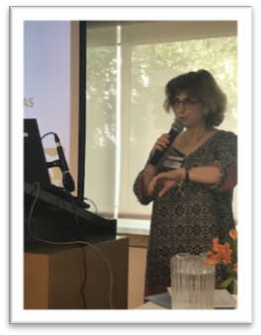

Dr. Shrieber is a lecturer at the Kibbutzim College of Education, Technology and Arts. She also oversees the technological department of the Mahut Center at the college, which provides counselling services to students with learning disabilities.
Dr. Shrieber began by noting that students with learning disabilities tend to have difficulty in cognitive executive functions, such as attention, impulse control, mental flexibility, etc. The current lecture focuses on working memory and how difficulties in working memory might affect performance in writing tasks.
Overview
- Writing tasks are the most common difficulty for which students turn to the Mahut Center to seek counselling. Why is that?
- Writing tasks feature different challenges for different learning disabilities, yet what they all have in common is the load it creates on working memory. For example, students with dysgraphia need to remember how to correctly write and spell the words; the working memory of students with ADD & ADHD is distracted by different internal and external stimuli that capture their attention at that specific moment; etc.
- These difficulties also make it more challenging for students with learning disabilities to pass the initial phase and start writing.
- Mind-mapping software is designed to help students with learning disabilities plan the structure and content of their writing tasks, thus easing the load on their working memory and making is easier for them to initiate the writing itself.
- The software provides visual representation for the structure and content of the task. The content can be represented in any form they choose, either textual or graphic.
- The students begin with associative writing, which makes initiation easier; then, by dragging and dropping any content they wish – text, photos, videos – they can begin organizing the task into topics and sub-topics. This way the software allows them to map their mind and eases the load on their working memory.

Mrs. Iris Adato-Biran – Kiryat Ono Acadmic College, Israel Assistive technology for learning applications, trends, and challenges

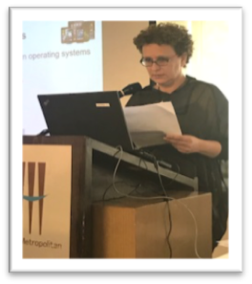

Mrs. Adato-Biran is an occupational therapist in the field of assistive technology for learning applications at Kiryat Ono Acadmic College. Her presentation focused on the subject of assistive technology for higher education students.
Overview
- Today, every higher education institute in Israel is obligated to promote accessibility in various ways.
- The center for academic support and accessibility at Kiryat Ono College provides students with tools for independent learning, such as learning strategies, time management skills etc., as well as assistive technology counselling.
- Today, many assistive technologies are available, some of which are more in use by students than others. These include software for reading and writing, text to speech, and programs for the blind and visually impaired.

Take-home messages
- Current challenges for assistive technology include data assessment, and student and staff learning and adaptation; they must also be included in the learning curriculum and open to all students, not only to those diagnosed with physical disabilities or learning disabilities.
- New technologies bring new opportunities; however, many times, students are unaware of the technology or weren't trained to use it, which makes the human factor crucially important.

Panels

International Panel - International Perspectives

Panel 1: Moderated by Batsheva Engelberg-Behr
The Open University of Israel

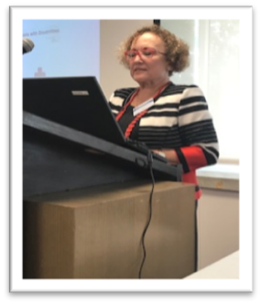

International Panel: International perspectives on search of new designs (Dan Comden, United States; Laura King, Canada; Björn Fisseler, Germany; Batsheva Engelberg-Behr, Israel; Tim Coughlan, United Kingdom)

Approaches to new technology design and development for disabled students
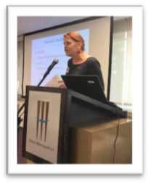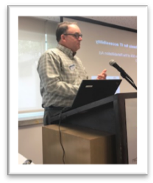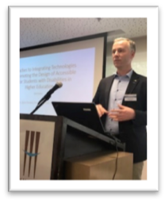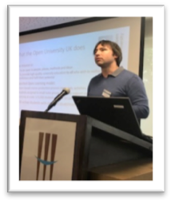
- United States
  - State laws, policies (e.g., WA Policy #188)
  - Provide accommodations for students with disabilities.
  - Computers with magnifiers and text-to-speech tools in the libraries
  - Continue with updates of our websites
  - Proactive approach for both applications and websites
  - Pre-pdf for many courses
  - Universal Design
Please see the PowerPoint at http://ed-ict.com/workshops/tel-aviv/programme/

- Canada
- Current Trends in Canada
- Mobile learning
- Cloud computing
- MOOCs
- Online courses
- Webinar

- Canadian Software
- WordQ, SpeakQ, Thought Q
- Word prediction software
- Text-to-speech
- Speech recognition
- Research tool
- Clockwork
- Administrative software

- Quebec Software
- Antidote
- Advanced correction and editing tool
- Lexibar
- Word prediction software

Please see the PowerPoint at http://ed-ict.com/workshops/tel-aviv/programme/

- Germany
  - Have Moodle, but haven't done accessible testing yet
  - Provide a lot of print materials
  - Students can get video captions
  - There is still a lot of enhancement to do

Please see the PowerPoint at http://ed-ict.com/workshops/tel-aviv/programme/

- Israel
  - Special standard for institutions of higher education that requires access to information:
    - Accessibility for Internet services
    - Accessibility of Digital Documents (SII)
  - Accessibility center in every university
- Start-up nation mobilizer, waze, Orcam’s glasses (new technology originally developed for accessibility)
Please see the PowerPoint at http://ed-ict.com/workshops/tel-aviv/programme/

- United Kingdom
  - Moodle as a natural environment, an open source platform
  - SensusAccess: Technology that allows the automatic conversion of documents into alternate media (audio books (MP3 and DAISY), e-books (EPUB, EPUB3 and Mobi) and digital Braille).
Please see the PowerPoint at http://ed-ict.com/workshops/tel-aviv/programme/

What is our university / college doing for its disabled students regarding new technologies?
- Canada
- Promotion
- Accessibility Center

- Evaluation
- Dawson’s Adapted Technology Lab
- CRISPESH

- Development and Design
- Not at our institution
- Some online courses

- Germany
Research on higher education:
- Diversity-sensitive introductory study phase.
- Diversity-oriented digitally-supported distance teaching and learning.
- Concept of inclusion of students with disabilities

- United Kingdom
- Our purpose is to introduce and integrate accessibility
- Have models to open access
- we work with research and turn it into practice
- Research in Practice:
- Enabling Remote Activity
- Graph Sinification pilot

- Israel
- At the forefront of countries that promote accessibility
- Since 2010 all new websites made accessible
- Research on distance teaching

- United States
  - Proactive approach for both applications and websites
  - Promote accessibility within context of UD, civil rights, and inclusive campus culture
  - Continually enhance website with checklists, how-to processes, plans, progress, resources
  - Offer training
  - Support multiple user groups
  - Proactively test existing websites and PDFs and train staff to remediate
  - Offer incentives (e.g., video captioning and PDF remediation pilots; Lynda courses)
  - Conduct state-wide Capacity-Building Institutes, and support state online Community of Practice

Challenges faced in Search of New Designs

- Germany
  - Lack of information about how many students need accessibility.
  - Management have no idea what to do with students with disabilities.
  - The technology was self-developed without accessibility online.
  - Budget limitations, assistive technologies and materials individualized for the student.

- Israel
  - Hebrew written from right to left.
  - There are no vowels in our language (funny mistakes with words that are written the same).
  - Hebrew language requires special tools in order to make sites accessible.

- United Kingdom
- In distance learning, the learner and the study setup is less visible.
- Assessment of individual requirements for UK Disabled Student Allowances (DSA) are conducted externally. Assessors may not understand the particular needs of online and distance learning.
- Agenda for increased online learning can cause problems, as well as opportunities. Printed materials and face-to-face tutorials are essential to many of our disabled students.
- Large-scale means that diverse individual needs meet with an institutional desire for standardised provision.
- Technology is not (all of) the answer.

Student Panel - Student Perspectives on the Search for New Designs
Panel 2: Moderated by Dana Kaspi-Tsahor – The Open University of Israel
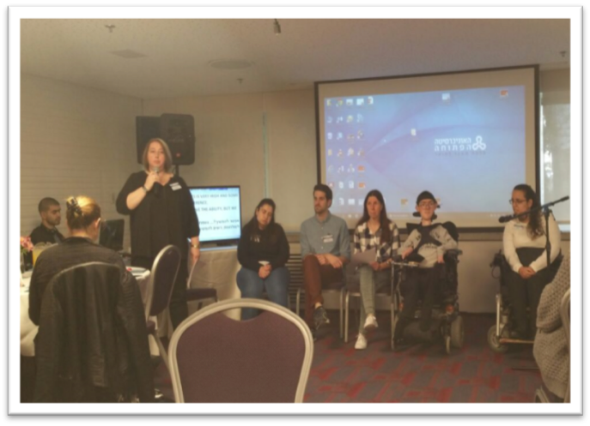

How has technology changed the way you study and learn?

- Technologies enable independent learning
- Technology gives me the ability to progress, to succeed, to express myself and utilize my potential.
- Without technology I would not be able to succeed as a university student.
- With a recorded book, I can prepare for the test independently.
- Summaries of the material and lectures are printed in Braille.
- The service for the blind helped me buy screen-reader software called 'Jaws' that converts the script into audio output and allows independent learning.

- Technologies enable distance learning
- Distance learning (from home) enables me to be a full-time student because I have a hard time attending all the lectures due to mobility limitations.
- The course site enables me to be at home and still feel part of the classroom.

Which technologies do you find especially useful? Why? How do you use it (e.g., for studying, in class, for exams)?

- For studying
- Software systems that allow me to type math symbols, complicated formulas, draw graphs and more
- I work with 'MathType' and Office 365
- Apps like Google are very helpful, I can learn not only at home, but also while traveling.
- I have all the material and studies on Drive
- I Use 'Zoom' software to hear the lectures

- In class
- Video lessons, in which every student can participate from home
- Radio-broadcast lectures allow you to actively participate in class by speaking and do not require typing.
- I use recordings of the lectures.
- The most useful technology for me is mp3 player.
- Windows recording software
- Recording through my smartphone
- I use 'Jaws' software during the lectures via headphones.
- By using Google Drive, I immediately receive the summaries of the lectures.

- For exams
- All the above are needed for exams

What else could technologies do for you that you would find helpful?

- Every class should have the technology to record its lessons on video.
- There should be an immediate translation, and not a process of transferring a PDF file to accessible files.
- There are still files that cannot be read with a screen reader and need to be converted by OCR; there are misspellings and things that have not been converted correctly.
- Distance learning classes should be translated into sign language or subtitles added.

What roles can various stakeholder groups take to promote the design of ICTs that are more accessible for disabled students?

- All the students chose not to answer.
"This question should be directed to Software development personnel."

How did you learn to use the technology that you use? Are you self-taught, or if not, who helped you?

- Self-taught
- Completely self-taught. In every assignment I learn something new about the software.
- I taught myself to use most technologies. It's all trial and error.
- Must practice a lot and find techniques as to how software can help most effectively.

- Peers
- I was assisted by an experienced student who explained how to use the software.

- Stakeholders at the university
- An access technologist helped me.
- I asked the librarian and lab technician many questions.
- I would not have been able to learn to use the technology without the technological instructor provided by the university.
- Just giving me the software is like throwing me into the water and thinking I'll be able to swim.

What support networks do you have for your use of technology; How do you learn about what’s new in technology that might be helpful to you?

- Support networks
- Using the technical support of the manufacturers from whom the technologies are purchased.
- Helpful friends and family.
- Assisted by a technological instructor on behalf of the Dean of Students.

- Updated
- Usually conduct my own research on the internet.
- Updates by newsletter of technology development forums, especially for Apple and Windows in the United States.
- Developer's technical support team updates about upgrades.

What difficulties, if any, have you encountered in your efforts to integrate new technology into your life? If you had problems, what steps have you taken to resolve them?

- Difficulties
- Integrating a new technology requires dedication.
- Economic difficulty – the technologies are very expensive.
- There is no such thing as problems; there are challenges.
- When the university revamped the online course sites, they became completely different in structure and it was difficult to understand where everything was located.
- The new online course sites were initially inaccessible to my screen reader.
- Over the years, Windows has evolved, and 'Jaws' software has not kept up.
- The sound of the reading software has improved, but it is still very metallic and unpleasant.
- There are still many errors in the reading software.
- Software does not read scanned texts.

- Steps to resolve them
- It's mostly a matter of a lot of practice.
- The university's technical support helped deal with changes in the website.
- I upgraded the JAWS program even though it cost a lot of money.
- I applied to the National Insurance Institute for assistance in funding the technologies.

Do you have any tech hacks: examples of where you are using a technology for a purpose or in a way other than how it was intended but in a way that really helps you?
- No, nothing in particular.

What difficulties did you encounter during exams, and how can technology alleviate the problem?

- Difficulties
- There are difficulties arising from dictating tests to neutral examiners, mainly in mathematics.
- Because I am unable see at all, I'm not sure if they wrote exactly what I said.
- The supervisor writes slower than I think, and it interrupts my thinking.
- The supervisors who write for us are seniors who write slowly.

- Improvements by technology:
- Print tests on the Braille keyboard
- Software for automatic transcription
- Recording exam answers

Audience questions:
Is there a software that you can dictate to, which records in writing what is said? Is there any such recommended working software?
- Currently, Google Drive's dictation works in Hebrew and it is quite accurate.
- Voice dictation exists for Apple, Google, and other systems.
- There are new software systems that write what you say, but at this stage, they are not yet suitable for academic needs.

Today, we see an increasing use of cellular apps in academic studies. Are native apps being increasingly used, or rather dedicated apps for people with disabilities?
- I frequently use smartphone apps.
- I use Native-Google, Google Drive, Google Docs, Google Sheets, Excel, and PowerPoint Slide apps.
- I use the 'Moovit' public transportation app. It is very helpful.

Thank you all for coming and providing us with valuable knowledge. This corresponds with Jane's opening lecture – that nothing can be developed without consulting you, the students, who express real needs. You can help undergraduates more than anyone else since you have insights that no one else has. This should be set in motion by connecting you with those undergraduates. This is a win-win situation that everyone will benefit from.

Discussion

Discussion – Day 1
Dr. Bjorn Fisseler – University of Hagen, Germany
Reflection on design
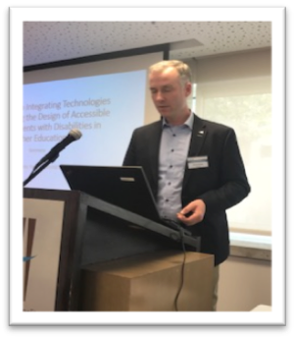

Dr. Bjorn Fisseler presented three parts of the discussion:
- What is design? What do we mean by design?
- A response to Jane's paper.
- Aspects which might be worth considering.

- What is design? As a verb, it means intending to do something. As a noun, building a product, making plans, drawing something. Design is about progress; the creation of new things. Design is ability and collaboration with others. When we talk about accessible ICTs, we want to make a difference for the students that we teach. It is a way of seeing and interacting with the world; a way of life. What are we designing? A product? A process? Developing new offers for students? Interaction with other learners? A learning environment? A market? A strategy?

- A response to Jane's paper - Measuring outcome. What are we measuring when we talk about accessibility? The success of accessibility? Academic success? Academic success can be measured at different levels, such as successfully completing a certain task. There are many indicators, such as the index of inclusion, which is problematic.
For example, consider subtitle usage in higher education. How many higher education institutions in Germany provide subtitles for students? They do not find it manageable to ask institutions. As of yet, there is no video management system able to measure the usage of subtitles. In addition, is it useful for individual students? It might influence academic success, but many problems do not have answers.

- Aspects possibly worth considering – The book Web for Everyone: Designing Accessible User Experiences, represents a new approach, as it develops a framework that consists of different guidelines: Putting people first, having a clear purpose, encouraging progressive enhancement, and easy interaction. A nice concept comes from the book Digital Outcasts by K. Smith, who argues as to why to invest in a small minority of users. After all, it is still considered a "niche" market, and inclusive design represents the downscaling of a product. This might be answered by Jeff Kline, the manager of the accessibility department at IBM. Whether public or private, it is always a management issue, and it is essential to have information. In order to achieve an institutional understanding, he argues for an accessibility policy, then a strategy, and then a work plan.
It is important to look at the USA; at how University of California presents accessibility technology initiatives and how they manage to continue. It is worth analyzing the initiatives with management approach.
The concept of agile development, as in "Agile Higher Education Didactics", is used in higher education. This approach encourages teaching and learning together with the students, according to what they want to learn, and then working together throughout the entire term through the first semester.
To develop accessible ICT, we need ideas for products that might be useful for students with disabilities. A book by Dianne Laureled, Teaching is an Art or a Science, states that in art "everything goes" but this is not true for teaching or science. Teaching is about what you want your students to learn. The principles and heuristics of practice.
The main question is, can we build patterns for accessible technology and learning?
Is our intention to fully allow students to participate in our seminars and courses?
Not everything has been fully thought through.
Psychological issues - When you do a workshop, you hope that the people will work more accessibly or with more principles of accessible design. What can change our daily practices? How can we change views and attitudes so that our work will be more accessible? Is it possible to change people?

Two concluding points
The first concluding point is Gartner's hype-cycle, and the second one is Robert's diffusion of innovation. When new technology appears, everybody wants to buy it; there is the hype, it drops, and then you have the plateau of productivity.

Discussion – Day 2
Prof. Jane Seale – Open University, UK
Discussion and future implications
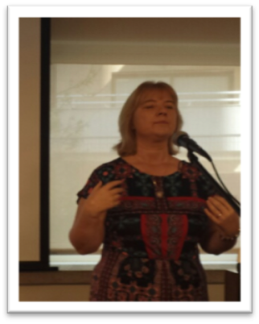

Prof. Seal: My job this afternoon is to try and reflect, as well as help you reflect, on what was said over these two days. What we tried to do here is to get people from five countries to share and to see similarities and differences; and also to come up with thoughts and ideas that will take the field forward internationally. Yesterday I put forth some questions: Are we willing to design better and accessible technologies? Do tools exist in order to design? Do all stakeholders need to be involved? And will this lead to better lives and outcomes for our disabled students and colleagues? I talked about design empathy and how we get designers to understand the needs and abilities of disabled students. I talked about inclusive methods.
Technology is not the problem; people are. My inspiration was Mr. Idan Meir. He said "technology is already accessible. But what about us? Are we willing to change?"
Please discuss this notion.
1st speaker: We feel the burden can be put on technology; accessible technology can truly empower people. But the same burden cannot be put on us, on people. It makes things really hard on people.
2nd speaker: The potential exists to make things accessible. Technology is not advanced and good enough, so many things must still be done by people. Technology can do part of the job. Our role is to identify the barriers from the human side, barriers for end-users and also for the ones that produce assistive technology. We must have good empirical research, and true awareness about the technological potential and needs. We also discussed affordability and it depends on delivery systems and again, on people; deciding who gets what.
3rd speaker: We discussed the exemptions from legislation, which is a barrier for accessibility. Cost is essentially a "people problem" too. There's also lack of skills, knowledge, the time needed to learn about accessibility and to implement it. Lack of accessibility for developer's education. The result is that people don't implement the technology properly.
Prof. Jane Seale: What I was looking out for over the two days are visions. What we heard: will it exist in the market? Is there new technology that we would like to see developed? For whom?
I was surprised by the student panel. They wanted to share with us strategies, and things they have learned, mindset, and so on. We need to design new strategies and support networks.
Elana Banish: In my talk yesterday about accessibility to service-based bots, my vision is to enter a mall and ask Siri to get the elevator; to further develop the technology needed to assist me automatically. For example, when I'm using a navigation map on my iPhone, sometimes there is a big crowd or another source of noise and I have difficulty navigating the screen voiceover. If I'm opening a navigation app I'd like to expand the possibilities of navigating to this or that store. I made my point.
Prof. Jane Seale: I like science fiction films and many films show this horror vision that A.I. will become more intelligent than us. What's so bad about that? The purpose of the A.I. bot is to make everything accessible automatically and to learn new patterns so it doesn’t need us and we don’t need new developers to design. What do you think?
4th speaker: I want to talk about a vision I love very much; the idea of having services in the cloud so when I come to a computer it can identify me and all the programs and data I need are automatically downloaded to this computer, wherever I go.
5th speaker: I remember that when I was a child my father had a noise device while driving – a device that woke the driver up if he fell asleep. Maybe the same principle can be applied to attention – something to alert people with executive functioning disabilities, to help them get refocused when their attention wanders.
6th speaker: We talked about Eye-Cam yesterday. I'm trying to be provocative: 4,500 dollars?? That's a problem, isn't it? Many of you spoke of affordability. I think government funding should go to companies only if they produce something that is open source, adaptive, etc.
7th speaker: I would like to follow this funding idea. Why not give the money to people with disabilities and they can decide what to purchase with it? Then the companies will follow the market and provide what people would like to buy.
8th speaker: I think that a very important question we must deal with that's related to the last offer is how we research the assistive technologies to assess when they're helping and when not. That's something we must deal with.

Summary

With a total of 93 participants and 13 international representatives (United Kingdom, Canada, Germany, United States and Israel), our conference represented various aspects from the academic, stakeholder, student and legal voices.
The presentations included:
- Students with disabilities
- Disability service providers
- University representatives
- Distance education representatives
- Access technologists
- Campus information technology staff
- Researchers
- Representatives of community organizations
- Lawyers
The following major activities were held:
- Keynote speakers
- Two panel presentations
  - International perspectives
  - Student perspectives
- Five sessions
- Two discussions

Keynote presenters
Professor Jane Seale suggested a new, critical frame of thought – one that would focus, not on how we can make technology assistive and accessible, but on how we can change society to make it accessibility-focused. She wondered if we, the academic community and the individuals who comprise it, were really willing to make the necessary changes. She suggested that we need a concept of openness, inspired by open-source technology.
Dr. Carmit Noa-Shpigelman presented a study aimed at learning what accessible technology means to people with disabilities; specifically visually-impaired people. She and her colleagues found that, while accessible technology could make its users feel equal to others and ease their lives, it could also accentuate their dependence on others and the uniqueness of their needs.
Topic 2 dealt with accessibility technologies in higher education. Various speakers presented the difficulties of students with disabilities, as well as technological solutions that are now being developed to address such difficulties. It was widely agreed that much has been accomplished in terms of finding accessible solutions for students with disabilities. Yet there's still a long way to go, and much empathy and awareness to accessibility is required from the designers who develop such technologies, as well as from the community as a whole.
Topic 3 dealt with the lives and experiences of students with disabilities. The speakers talked about the importance of students with disabilities being able to learn and experience growth through their academic education and how much personalization of solutions for each student's needs was required. Again it was agreed that much still needed to be done in terms of awareness and empathy from the general community.
For topic 4, which dealt with future directions in promoting new designs in higher education, two studies were presented. The first study, presented by Prof. Lilach Shalev-Mevorach, dealt with eye-tracking and reading comprehension in students with ADHD. The second study, presented by Dr. Sigal Eden, looked at the assimilation of students with cognitive disabilities into regular academic courses.
Topic 5 centered on new technologies and software designs designated to promote accessibility, and the challenges involved in designing and implementing such technologies.
Details and specifics related to the kick-off, the keynotes, and the various topics discussed are too numerous to summarize here. These are available in the above sections of the proceedings.

International Panel
The diverse perspectives of the international panel revealed that the five countries represented were in different stages of development and were often focused on different things. The United States is still updating courses and materials to make them accessible, but is taking a proactive approach in reaching out to students with disabilities and training them in technology usage. The situation in Germany is quite equivalent: there is still much to do in terms of updating relevant sites and learning materials, but there is much awareness and orientation to diversity. Canada offers students many tools and technologies, but is currently more oriented to mobile learning and cloud computing. In the United Kingdom, there is an emphasis on research-based, empirically-validated solutions, as well as open source technology. Israel is at the forefront where accessibility is concerned, promoted both by legislation and technological development, however the use of the Hebrew language and letters requires many modifications and alterations to accessible technology.

Student Panel
The student panel was asked to discuss their use of technology and to describe how technology assists them. Students noted that technology made them more independent in their studies and enabled them to take part in distance learning. When asked about the technologies they find most useful, many of them noted software for video & audio recordings. Many students also noted that speech-to-text/sign language software still needs to be added and improved. Many of the students taught themselves to use accessible technologies; some mentioned learning from peers or from university personnel. Problems with accessible technologies tend to emerge when updates are installed, or when one software is more developed than another; other difficulties surround technologies that aren't developed enough yet (such as text-to-speech technologies).

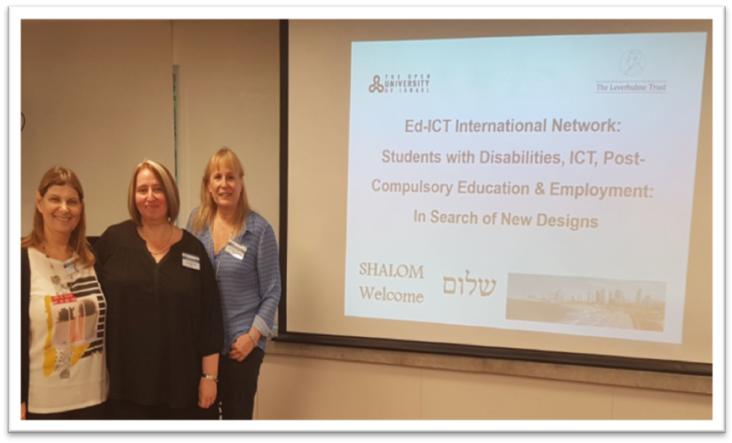
The Israeli Team, from The Open University of Israel
Thanks

We thank all the participants for attending and participating in the Third ED-ICT meeting in Tel Aviv, Israel. We are very grateful for the shared ideas and concerns, for the useful advice, and for initiating local and international collaborations. We appreciate our guests taking the time to share their experiences and discuss possible future solutions.

Symposium Participants

The following individuals participated in the symposium.

Iris Adato-Biran
Ono Academic College
Israel

Nitsan Almog
Ono Academic College
Israel

Matan Bar-Noy
OrCam Technologies
Israel

Eilana Benish
Accessibility Coordinator
Israel

Chetz Colwell
The Open University, UK
United Kingdom

Dan Comden
University of Washington
The United States of America

Tim Coughlan
The Open University, UK
United Kingdom

Markus Deimann
FernUniversität, Hagen
Germany

Batsheva Engelberg-Behr
The Open University of Israel
Israel

Sigal Eden
Bar-Ilan University
Israel

Catherine Fichten
Dawson College and Adaptech Research Network
Canada

Björn Fisseler
FernUniversität, Hagen
Germany

Alice Havel
Dawson College and Adaptech Research Network
Canada

Tali Heiman
The Open University of Israel
Israel

Dana Kaspi-Tsahor
The Open University of Israel
Israel

Laura King
Cégep André-Laurendeau and Adaptech Research Network
Canada

Moshik Lavie
The Open University of Israel
Israel

Idan Meir
RightHear
Israel

Goly Rabbanim
The Open University of Israel
Israel

Dorit Olenik-Shemesh
The Open University of Israel
Israel

Michal Rimon
Access Israel
Israel

Eliav Rodman
OrCam Technologies
Israel
Israel

Jane Seale
The Open University, UK
United Kingdom

Lilach Shalev-Mevorach
Tel-Aviv University
Israel
Michal Shik Har-tuv
Acces Israel
Israel

Carmit Noa Shpigelman
University of Haifa
Israel

Betty Shrieber
Kibbutzim College of Education
Israel

Yuval Vagner
Access Israel
Israel

Michal Waltner-Levi
Google Israel
Israel

Hadar Zeltzer Fallah
V.P. DAGESH, Israel
Israel

Acknowledgements

Funding was provided by The Leverhulme Trust and by the Social Sciences and Humanities Research Council (Grant # 611-2016-0657). Any opinions, findings, and conclusions or recommendations expressed in this material are those of the symposium presenters and project staff and do not necessarily reflect the views of the funders.
We wish to thank The Open University of Israel for their funding and support, and to acknowledge the substantial help of our staff:

Assaf Shambi
Hanny Shalev
Yardena Iffrah
Bat-Sheva Engelberg-Behr



Shoham was established in April 1995 as a professional organization focusing on the informed integration of information technologies into the Open University of Israel teaching paradigm. The Center deals with the development, evaluation, research and integration of technology-based pedagogical solutions to meet the various needs of academic courses offered by the University, enabling it to provide a higher quality and more effective and enjoyable learning experience to its varied and dispersed student body. https://www-e.openu.ac.il/geninfor/shoham.html

